**Budkkaaa**

**Home |** Shop | About | Contact | Visual

**Coquette disaster The day**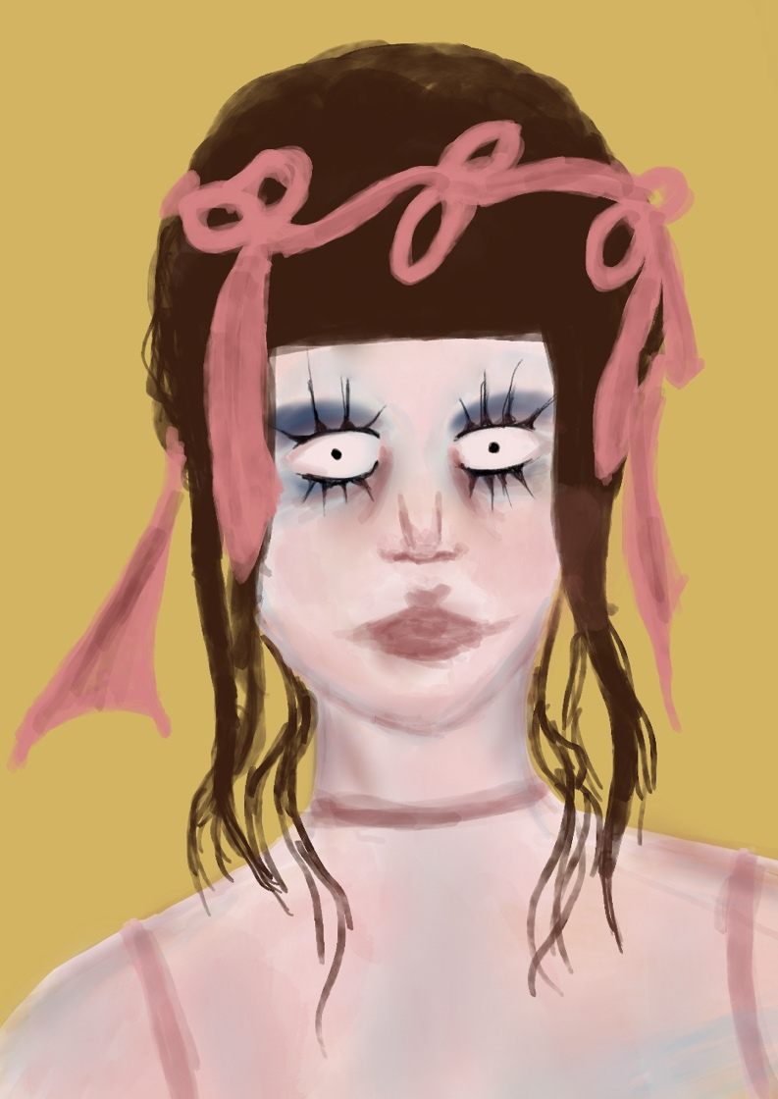

**Running out of time Gemini**

**Attachment Uur Tsaikhad**

**Aura Loneliness**

**Budkkaaa**

Home **| Shop** | About | Contact | Visual

|  |  |
| --- | --- |
| **Art name** | **Price** |
| Coquette disaster | **50€** |
| The day | **50€** |
| Running out of time | **50€** |
| Gemini | **50€** |
| Attachment | **50€** |
| Uur tsaikhad | **50€** |
| Aura | **50€** |
| Loneliness | **50€** |

**Budkkaaa**

Home  **|** Shop | **About**  | Contact | Visual

ABOUT THE Artist

Hi, I'm Budsuren, also known as Budka, an artist specializing in digital art based in Ulaanbaatar, Mongolia.

My preferred tools are my iPad, iPen, and iArtBook. I thrive on infusing texture, color, and, most importantly, intense emotions into my creations. Drawing people in various poses and emotional states brings me immense joy.

My inspiration stems from everyday objects, human emotions, and the ever-changing weather. Essentially, my art is a reflection of my daily feelings and the emotions I encounter.

//Background photo will be displayed.

**Budkkaaa**

Home  **|** Shop | About **| Contact** | Visual

For general or work inquiries please contact me at bbudka196@gmail.com or via form below.

Click to start writing.

  I accept only necessary cookies

 I accept all cookies

Submit Reset

 

Your message*

Your name*

Your e-mail*

* I'd like to receive new product updates via e-mail.

**Budkkaaa**

Home  **|** Shop | About | Contact | **Visual**

Here I present a time-lapse video demonstrating the creation of one of my artworks.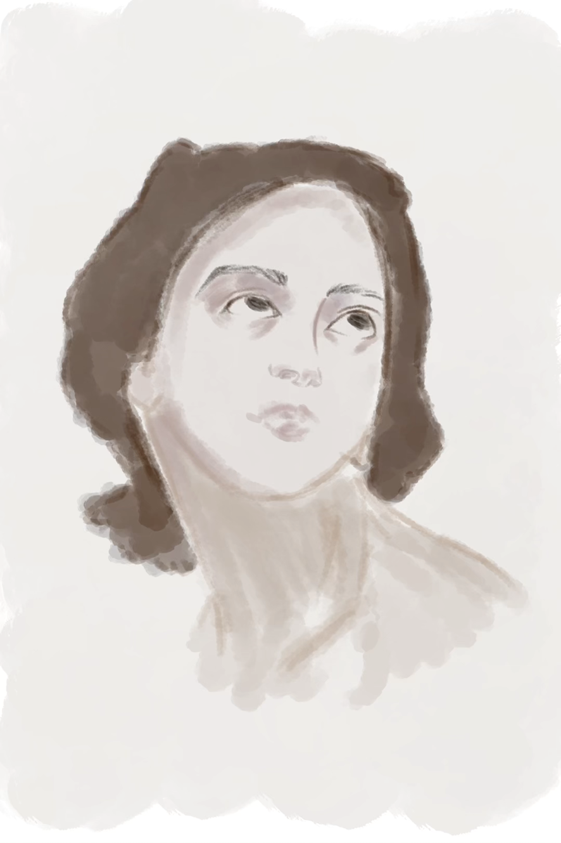

Each stroke of my brush, each splash of color on canvas, carries with it a story, an emotion, and a vision of a world beyond our ordinary perceptions.

They are reflections of the emotional landscapes I've traversed, capturing moments when I've felt at my lowest lows or soared at my highest highs.

List of song recommendation for you to create art while listening to them:

<https://youtu.be/G29uo9whmZM?si=0eVEi6HW3w2pZb6K>

<https://youtu.be/ECanzDT7dmo?si=Dj27gOJ0b32Zq7Li>

<https://youtu.be/tyQt-vG6UpI?si=SuM1XrK7SjpNy8JJ>